Introducing column subtraction lesson plan

Subject: Maths Lesson Title: Introducing column subtraction
Date: | Time Span:
Year Group: Year 3 | Group Size: 30

Desired Learning Outcomes  To be able to subtract in columns (without borrowing) | NC PoS ref:

Key Language:  Column, horizontal, vertical, units, tens, hundreds, thousands and tenths | Use of ICT:  Smartboard for introduction

Assessment (Make reference to each section of the lesson)
Intro – Level of work based on ongoing assessment
Main – Mark children’s work as they complete it. Sit with any children who are struggling, bringing them back to the carpet if necessary. If still unsure by end of lesson sit with TA during plenary.
Plenary – Can children explain their working out to a partner, using the correct terminology e.g. column, units, tens etc?

Use of Other Adults
TA to work with lower ability at start of lesson
TA to monitor progress of children once they begin working
TA to sit and continue working with children (of any ability) who struggled in plenary

Anticipated Misconceptions/Difficulties
Children starting on the left (this will be problematic when borrowing is introduced)
Children not putting numbers in the correct columns e.g. putting units under tens
Children not putting only 1 number in each square and thus getting columns confused
Children forgetting to write the - sign to show the operation being calculated

Resources
Tens sticks
Squared paper for plenary
Success criteria left on each child’s table (not for lower ability)

© www.SaveTeachersSundays.com 2013

Introduction  TA to take children who are unable to subtract a 1-digit number from a 2-digit number (e.g. 47 - 6) and / or are unable to subtract multiples of 10 (e.g. 40 - 20)  Practice counting down from 100, especially focusing on crossing tens barriers  Practice counting down from 100 in tens  Calculate mentally by putting first number in head and counting back, using fingers to keep count  Work on setting these questions out in columns and calculating them mentally  Go through PowerPoint with the following:  - Explanation of the difference between horizontal / vertical and what a column is  - Example of how we will be setting out our work in 2 different ways for each question today (with partitioning and without partitioning – this reinforces the idea that without partitioning a 1 in the tens column is a ten, not just a unit):  - Subtracting 2-digit and 3-digit numbers e.g.  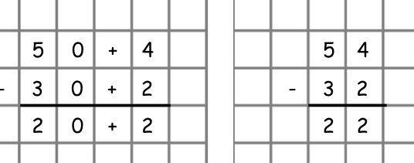  (With every example reinforce four main teaching points:  - Start on the right-hand side  - Put only 1 number in a square  - Write the -  - Put units under units and tens under tens and so on  - Examples of subtracting covering differentiation below  (After doing the example before the decimals, have middle and higher ability go and stick success criteria in their books)  - Final slide with reminders of the 4 key points above (success criteria)  Remind children to leave space between calculations and not squash them together  Have a copy of the success criteria to stick at the top of their page on each child’s desk (except for lower ability as they do not need to think about all of the criteria) | Time  15 mins
Main (including differentiated tasks)  (At regular intervals have children stop and check their work against success criteria)  Lower ability – subtract 1-digit numbers and multiples of 10 (give units squares and tens sticks if really needed)  Middle ability – subtract 2-digit numbers (no borrowing)  Higher ability – subtract 3-digit numbers (no borrowing)  Extension – subtract 4-digit numbers and numbers with decimal places (no borrowing) | 20 mins
Plenary  Have children self-asses their work against the success criteria  In ability partners give children 1 question to do each  Children need to talk to their partner, explaining what they are doing e.g. I will put the 3 under the 5 because they are both units. Then I will put the 40 under the 20 because they are both tens. Then I draw my equals line with a ruler. Then I start on the right and subtract the digits first and then subtract the tens  Children swap over and partner who spoke first now listens | 10 mins

© www.SaveTeachersSundays.com 2013

